Virtual Life Assistant

## Market Need and Size

The market of intelligent virtual assistants (IVA) is growing very fast because of the croissantly increasing need for time management and improvement in productivity. According to Mordor Intelligence, the global IVA market is tipped for substantial growth, reflecting strong traction across various sectors. Indeed, as it is estimated at USD 14.77 billion in 2024, it is expected to reach USD 60.83 billion by 2029, growing at a CAGR of 32.72% during the forecast period.

Statista also envisions high growth of the AI market with virtual assistants, up to $184 billion by 2024. Furthermore, applicative productivity software is assumed to experience an augmentation of 2.73% per year for 2024-2028, thus accumulating a market volume of $88.05 billion. In all, these trends are promising a compelling market opportunity for AI-based virtual life assistants related to the effective and efficient planning of personal and professional time management.

## Competitors Analysis

Current leaders in this space include Microsoft's Cortana, Google's Assistant, and Apple's Siri, with functionality that spans from basic scheduling and reminder support to the advanced integration of third-party, smart-home device functionality and applications. However, despite being incredibly popular, the learning capabilities of these platforms fall short of providing a highly personalized and proactive scheduling solution.

They predominantly provide a form of reactive assistance, where their main focus is on responding to user commands rather than supporting the user in their needs by proactively trying to anticipate them and optimizing schedules according to the preferences and habits of each user. This represents a gap that only a more personalized and intelligent life assistant, capable of learning from user behavior and giving dynamic scheduling solutions, can fill.

<https://www.usemotion.com/>

## Targeted Audience

The primary user of the Virtual Life Assistant includes busy professionals, students, and individuals who have many daily commitments. Personas for this audience might include:

* Emily, the Overwhelmed Professional: 35-year-old project manager with many meetings, deadlines, and personal commitments, requires an assistant to integrate with her calendar at work, prioritize tasks, and remind her in time.
* Alex, College Student: A 21-year-old student is juggling classes, study groups, part-time work, and extracurricular activities. Alex needs something to organize them around assignments and to schedule study sessions so they can be sure to make time in their schedule to maintain a decent balance in their social life.
* Sarah, the Entrepreneur: Sarah is 40 and manages her enterprise. At times, she is therefore required to run multi-business operations, getting involved in client meetings. Sarah would consequently require an assistant who would help put her in line with her business and personal schedules to ensure she is at her best when it comes to being productive.

## Summary

With time and the ever-expanding need for efficiency and productivity, the market for intelligent virtual assistants has increased. Although players reigning in the market are Cortana, Google Assistant, and Siri, personalization and proactivity in scheduling are the demanded features. Functionalities are being provided at a basic level only. Targeting busy professionals, students, and entrepreneurs allows the new functionality of the Virtual Life Assistant to fill the gap, offering dynamic and intelligent reinforcement of scheduling. With good market potential and identified demand in the target audience, developing such an AI-based solution creates a promising innovation and business success potential.

(write down a pitch from this)

## Lean Canva

First draft

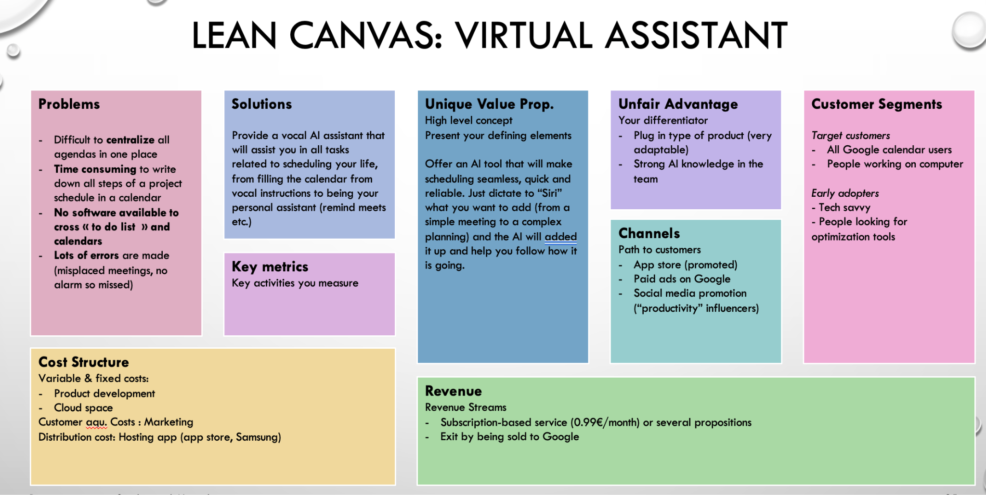

## References

Mordor Intelligence. "Intelligent Virtual Assistant Market - Growth, Trends, COVID-19 Impact, and Forecasts (2023 - 2028)." Retrieved from [Mordor Intelligence](<https://www.mordorintelligence.com/industry-reports/intelligent-virtual-assistant-market/market-size>)

Statista. "Artificial Intelligence - Worldwide." Retrieved from [Statista](<https://www.statista.com/outlook/tmo/artificial-intelligence/worldwide>)

Statista. "Productivity Software - Worldwide." Retrieved from [Statista][(https://www.statista.com/outlook/tmo/software/productivity-software/worldwide](https://www.statista.com/outlook/tmo/software/productivity-software/worldwide))

TO DO LIST FOR FRIDAY?

Lean Canva: Olivia (send a version today to teacher)

Presentation deck init: Killian, Olivia

(always the slide and pitch that goes with it)

<https://docs.google.com/presentation/d/1XmgqQFDHHgVcFVhBSgYiAcTKQSR3jMNnOLZGHbGbp6Y/edit#slide=id.p>

* How many tools do you use to plan your life ? Which ones ?
* From 1 to 10, the level of stress that comes from planning/scheduling ?
* How often do you get in trouble because of mistakes in your planning ? (once a week etc)
* How do you deal with stress (eating, sport etccc) ?
* Hook sentence,
* problem definition,
* value proposition: pitch solution
* demo of the POC,
* technical solution,
  + plug any calendar (competitive advantage)
  + MVP -> customer journey real product
* impact of the solution,
* positioning of the solution (market, etc.),
* deployment strategy,
  + technical:
  + financial: exit
  + marketing:
* next steps,
* the **final touch**: you want to try yourself ? -> QR Code

Pipeline LLM (from text to add in google calendar):

* OpenAI: PK
* Google API: Robin

Stream lit interface: Juntao

Speech-to-text Whisper API (if we have time)

*First ideas for presentation*

***Introduction (Hook sentence + Problem statement)***

We all have been faced with the situation where our planning skills were proven to have been pushed to their limits. Apart from being time consuming (writing down by hand all steps of a project in a calendar), the mental load that comes from planning, prioritizing and making up for prior mistakes is non negligible.

According to the …, (analysis)

* How do people schedule ?

[Time Management Statistics & Facts - Acuity Training](https://www.acuitytraining.co.uk/news-tips/time-management-statistics-2022-research/)

* reasons behind burnouts

[How managers can protect themselves from burnout | Employee Benefit News](https://www.benefitnews.com/news/how-managers-can-protect-themselves-from-burnout)

* reasons behind stress

[Stress Statistics UK | 2023 Data | Champion Health](https://championhealth.co.uk/insights/stress-statistics/)

* Statistics on benefits of better time management.

[Time Management Statistics New Research in 2022 | Timewatch](https://www.timewatch.com/blog/time-management-statistics-in-2022/)

Bad management leads to :

* x hours a day

**Solution (Value proposition + demo of the POC)**

Applying that methodology: 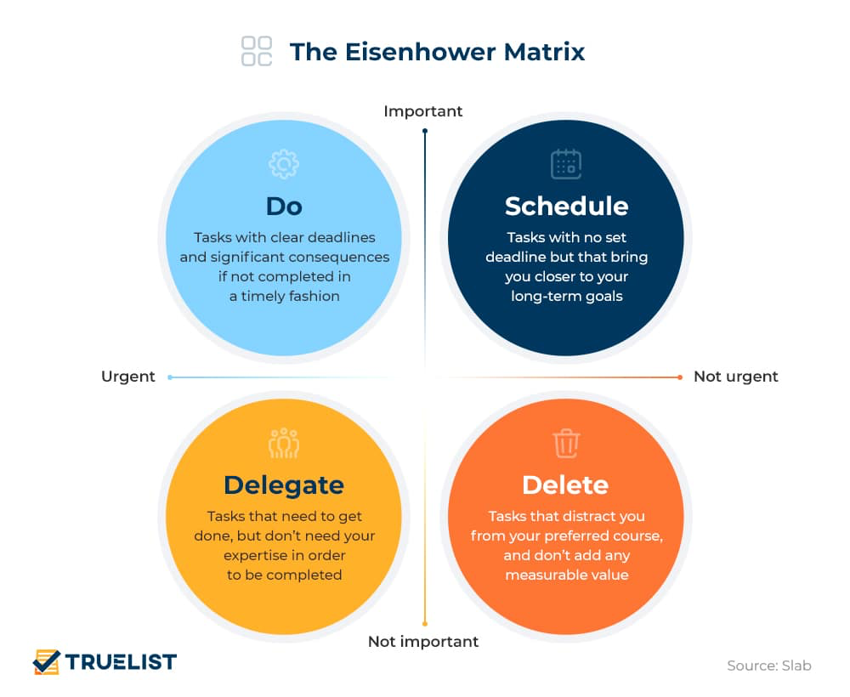

What if our AIscheduler could do it for you ?

***Class survey***

|  |  |  |  |  |
| --- | --- | --- | --- | --- |
| ID | How many tools do you use to plan your life ? Which ones ? | From 1 to 10, the level of stress that comes from planning/scheduling ? | How often do you get in trouble because of mistakes in your planning ? (once a week etc) | How do you deal with stress (eating, sport etccc) ? |
| 1 | Google calendar, alarm, moodle | 2 | 1 out of 10 times | eating/sports/procrastinating/smoking/drinking |
| 2 | Notion, note, google drive, apple calendar, 6 emails (but linked) | 6 | 1 a week | isolate yourself, think about a solution |
| 3 | Google calendar, manual writing | 1 | once a month | watching, sleeping, going out |
| 5 | Personal diary, Notion | 3 | 5 over 10 | running, playing guitar |
| 6 | Google calendar/reminder app | 7 | 0 | drinking/smoking |
| 7 | asana, google calendar | 2 | 1 month | sports |
| 8 | to do list/tableau excel | 3 | 1 par mois | ignore |
| 9 | notion | 0 | 1/2semaines | méditation |
| 10 | calendrier apple,paper notes | 3 | 1par mois | ignore |
| 11 | Google calendar | 6 | 1 a month | watching video/tv show, sleeping |
| 12 | Google calendarAwesome calendar, TXT, notes, Google Calendar | 63 | 1 per 3 months1/month | workout/sleeping/eating |
| 13 | notion, apple to do, calendar google | 4 | 0 | ignore, sport, go out |
| 14 | notion, obsidian, notes, Google calendar | 4 | 0 | eating, sports |
| 15 | Google calendar | 0 | 0 | 0 |
| 16 | Hand notes, google calendar, notion, physical agenda | 7 | 1 a week | ignore, sports |
| 17 | Google calendar | 6 | 1 every 2 months | sports/going out |
|  |  |  |  |  |